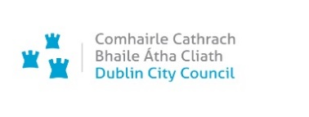

While Dublin City Libraries reopens on a phased basis over the summer, you can access eResources for children of all ages for free like e-books, e-audio books, comics and much more. Have a look at our online resources and see what’s available.

All you need is your library card number.

If you don’t have a library card number, you can sign up for one online here
While libraries are closed, you do not need to finalise your application in the library before being able to use online services.

If you are interested in the Summer Stars reading challenge, click on the following link Summer Stars 2020 for more information and then contact your local library to register.

Keep an eye on our Dublin City Libraries website for further online activities over the summer.

